MLS Feature:

Usage Description:

When a user selects the “compare” link on the polygon, a data pop up opens displaying fields and data. See pictures below:

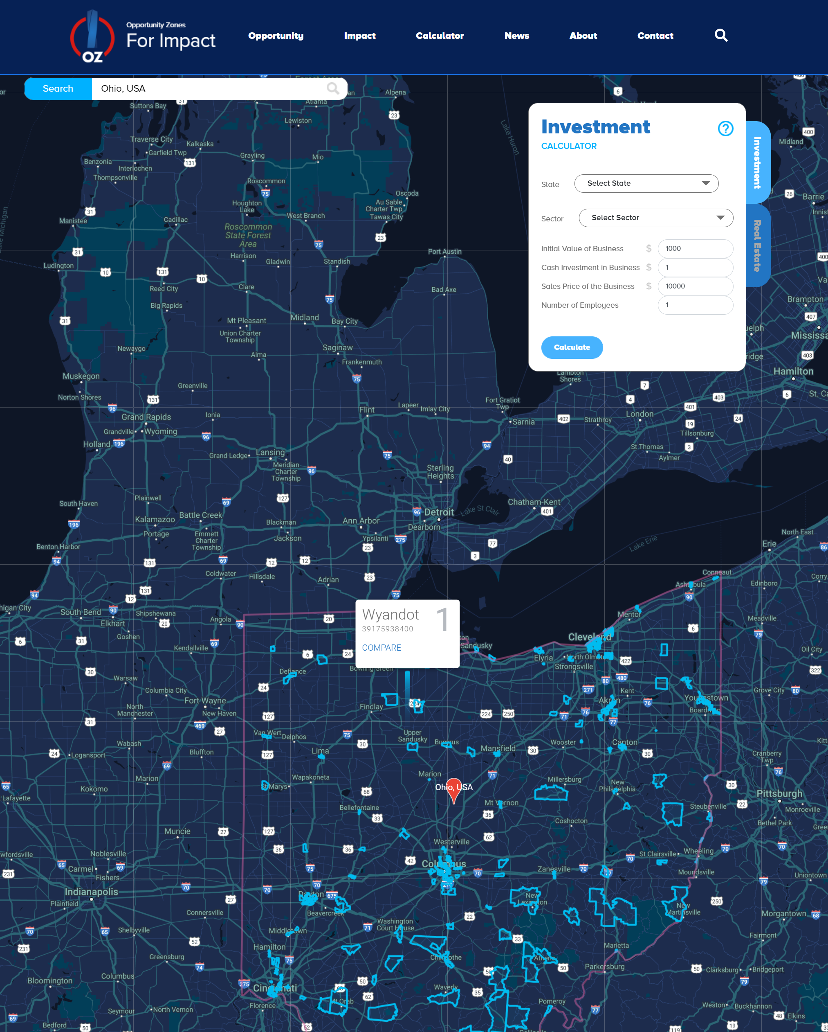

In the red line next to the State name, pictured below, there will be a link entitled, “Get properties for sale”.

This link will do the follow:

1. Get all for sale listing for this polygon from Zillow. The scrape must be fast and avoid disruptions from Zillow. 3rd party services like Apify are fine to use.
2. Display listings on map for the selected polygon, just like Zillow. Each dot will be a link to the url for the Zillow id (zid) and open upon on another page – just like Zillow interaction.

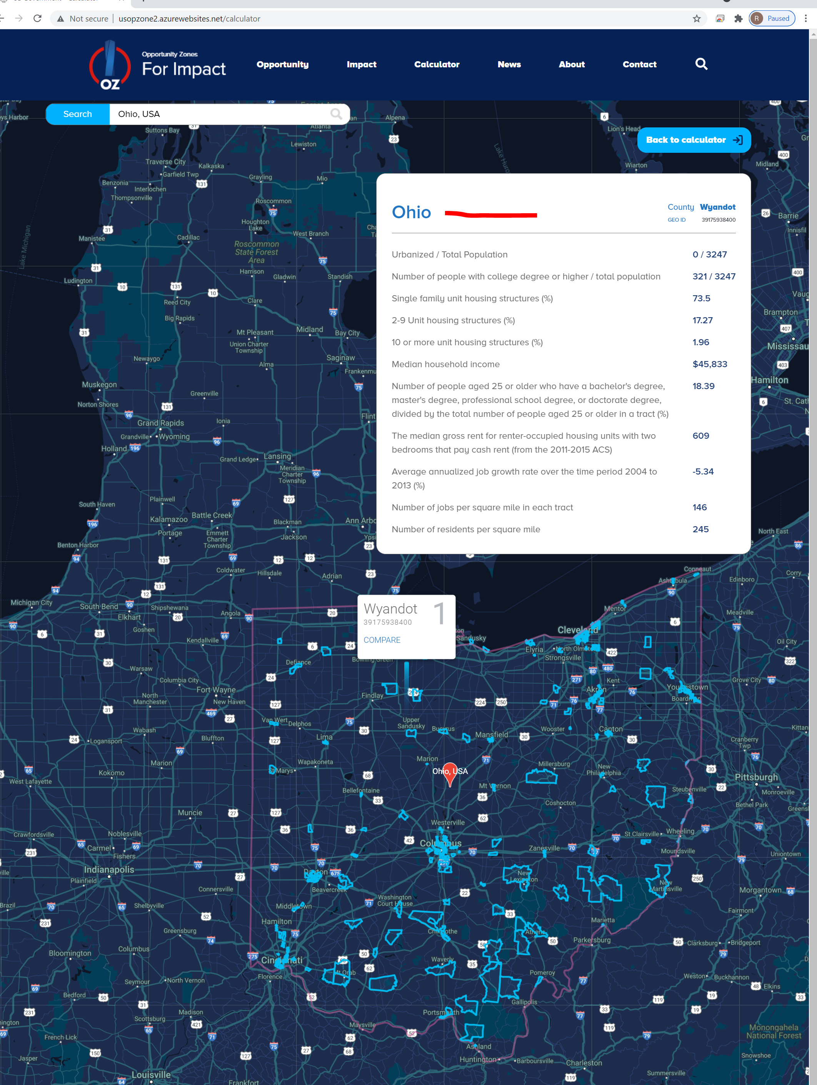

For example, this is an example of the Zillow map display:

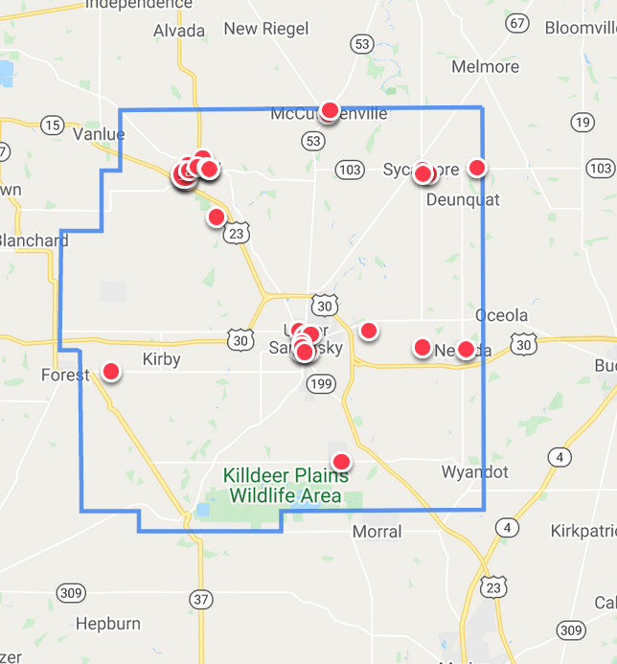

The same mouseover and links should be copied over.